ERR Anti-Social Cycling Challenge 2010
Newcastle to Stirling, August 20th-23rd

The Cast
(in alphabetical order)

3-bikes Ben
Bollard Denise
Butt-Stripe Derek
Foghorn-Leghorn Graham
The French Lieutenants Woman Ian
The King of the Mountains Jane
Sparrow Julie
Spike Marisa
Tea-Stop Larry
Techno-Boy Lesley
Tyre-Toucher Linda
***-upon-Tweed Tony

Note that both lists are in alphabetical order, so they do not correlate as they are listed (e.g. Ben is not “3-bikes2), etc. The list on the right is simply to remind you who was on the trip. If you can work out who is who then well done to you!!! First correct analysis by email to Lesley (lesleypj@googlemail.com) wins a cheap bottle of plonk!

Day 1: Newcastle to Ashington, report by Butt Stripe
33 miles
2hr 50min (in the saddle)
585m of ascent
Terrain types: tarmac, cobbles, broken glass, sand and grass.

Tea-Stop and I met at the residents of Bollards and 3-Bikes. Everyone else was excited yet relaxed and patiently awaiting the arrival of The French Lieutenants Woman with the van. Loading went well with ***-upon-Tweed overseeing with the Tyre-Toucher supervising (hope you are with me on this, as it’s so confusing for me!).
All was well until we left. Bollard nearly drove us into the ditch within 3 yards of leaving! Somehow he had convinced us he was best at negotiating the gate! Doesn’t say much for the other nominated drivers! “Will we get there safely Tea-Stop asked?” “Too early to say” I replied as I could feel Tea-Stop gripping on to my arm and checking the seat belt was fastened securely. Only another 300 miles or so to go!
Surprisingly we had travelled quite some way before The French Lieutenants Woman needed to stop. Perhaps it’s cycling that puts pressure on her bladder which causes the need for multi stops.
We stopped at another service station for refreshments, so Tea-Stop & I went for a cup of tea, what else, and a burger. We were out of the bus first so went to McDonalds to get in the queue first. Everyone else went to the restaurant across the other side! Was it something we said?
We needed to stop again towards the end of our journey, to dress ready for action. Just before we arrived at a safe place, the weather deteriorated slightly and we had a gentle shower. I kid you, the heavens opened like you hadn’t seen before. When we got out the bus there was a newly formed river running through the car park! I was going to help Tea-Stop cross this river, but it was far too wide and it was still pi... raining heavily, no it was even heavier than you are thinking, so I waited for her undercover like a gentleman would.
We had travelled in casual clothes and changed at a service station. It was a bit like ‘Make me a Star’ (I think that’s what it was called) without the smoke! We went into the loos all casual, reappeared in ERR cycle outfit feeling a bit embarrassed. Never mind, there seemed to be dozens of us. Blue and white everywhere.

We arrived safely in Newcastle, thank you drivers – phew! Now for the first ride. All we had to do, was follow Techno-Boy with his sat-nav or Bollards map to get on the cycle track at the train station. With all the gadgets and map reading skills we had in the team, it was going to be easy. I think we cycled round and round and round Newcastle but never did find the train station!
While cycling the first part of the route we soon got to know the area we were in. Would it be upper class we thought? Before we had even got out of Newcastle we had seen drunks lying on the cycle path (would fit in well at ERR) and a little later we were taken off route slightly around a cordoned off murder scene. Tea-Stop and I had a long chat during the journey up on how far this was going to be. At the first meeting we attended it was going to be a gentle 20 something miles starting at 3.30 pm, then later we discovered that was the direct route on main roads, it was going to be just over 30 as we would take the scenic route! We should have guessed, it was 33 and felt more like 53, but it was a lovely route along paths and ex-railway lines, following along the coastline, passing many wonderful beaches. Tyre-Toucher fancied a swim but the race was on to get to the hotel in time for a beer or two and dinner. Well, what would you have done – swim or beer and dinner?
Tea-Stop and I agreed that whether the next day was going to be more or less hilly needed to be discussed over a beer later, just to determine how many beers we would need to get us through the 72 miles or so.
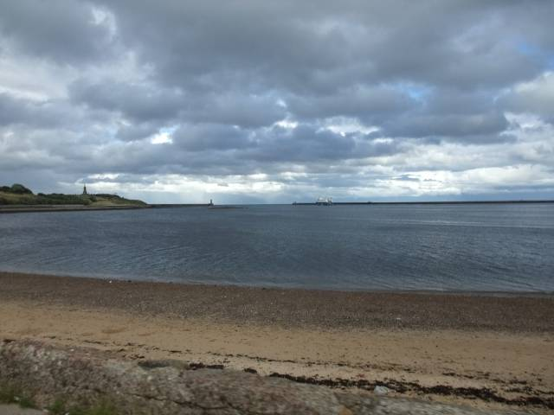
Evening meal, what did I have? All I can remember was that it was very enjoyable but Bollard and I were longing for a pint or two of northern real ale but none available, ah well the red wine was wonderful. The discussion we had over the flat or undulating or downright hilly route tomorrow was informative yet confusing. Bollard said it was going to be flat (his map showed the profile, it looked flat) that was fine until Techno-Boy shared his view with us! He also had a printout of the route profile. None of it looked flat. Mustn’t show that to Tyre- Toucher, I agreed with Tea-Stop! Let her know when she’s slightly dazed with the intake of wine, it won’t be long!
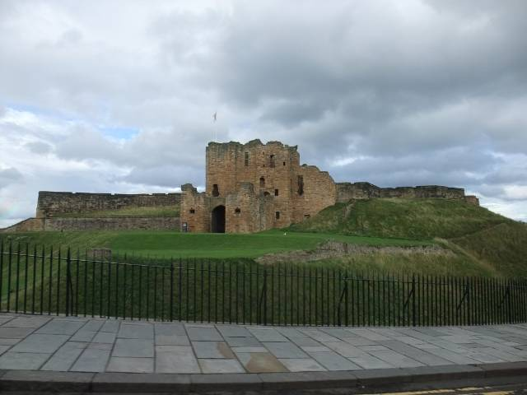

Overall though, the first day was fantastic, with many many laughs and many many punctures!

Day 2: The Day with Holy Island, report by The French Lieutenant’s Woman
80 miles
7hr 10min
1010m of ascent
Terrain types: tarmac, gravel, mud and sea water.

After a good night’s sleep for most in the delightful Premier Inn (just how delightful we did not fully appreciate at that time), I woke up in a panic about my builder who was due to arrive on Monday, and needed to use the internet so I could forward an important email to the French Lieutenant. I decided that my best bet was locate Sparrow who was sharing a room with Techno-Boy, and I was amazed to find that they had turned a Premier Inn room into something resembling a computer control centre overnight, and was lucky enough to be invited in for a pre-breakfast stint on the Sparrow’s netbook. Job done, I went downstairs to meet the others for breakfast downstairs at 8am in the restaurant, where most were opting for the full english breakfast. I obviously had left a trail of destruction behind me in the control centre because Sparrow and Techno-Boy did not appear for some time, and created all sorts of havoc by asking for refunds on the breakfast and Sparrow ordered a huge fry up when everyone had gone upstairs to brush their teeth and get ready to go. This was to set the tone for the rest of the trip!
Out in the car park, pumping up tyres and waiting for the breakfasting Sparrow, a photo-shoot was suggested and a lamp-post location proposed in jest by the Bollard. He said it with such authority that the ladies in question happily obliged. Tea-stop took the pressure off Sparrow with a last-minute glove-finding foray, and finally we were on the road. Not for long! The Sustrans route we followed was in a meandering mood and seemed to enjoy directing us onto gravelly paths rather than nice smooth roads. I was glad that Techno-Girl was not there as she would surely have thrown a wobbly. A group decision after some miles was to divert to Techno-Boy’s “alternative” route which would take us back on-road. Good choice, and many thanks to TB for the many evenings spent drawing maps on his computer (and TG for putting up with it). I think we might have cycled past a good castle or two, but we were saving our castle-stoppage time for Bamburgh castle where we were due to swap drivers. Time for the first puncture of the trip from 3-Bikes who was at the time at back of the group with a bunch of girls. The tailwind we had been enjoying was so strong that by the time the traditional pit-stop team (***-upon-Tweed and Sparrow: we missed you Tich!!!) had reached the girls, they had sorted themselves out, thank you very much!
The first official stop was in a village called Embleton, where the wonder of Google Satellite had been used to good effect to find the perfect grassy layby for Bollard to park up in. However, some builders had also decided this was a good place to have lunch and we had to be very careful where we peed. I do believe that the Tyre-Toucher may already have had her first puncture by then (albeit a slow one which she kept pretty quiet) and the opportunity was taken to replace a suspicious inner tube.
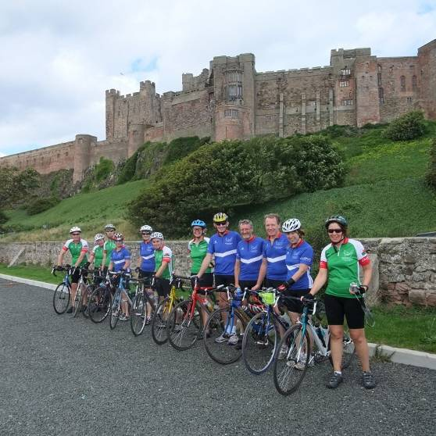
Onwards to Bamburgh Castle where some opted to cycle right up to the castle gates and others to stay down in the car park for an ice cream. During the obligatory photo-shoot with castle in the background, we realized that we were way ahead of schedule: we had 3 hours to cycle the next 15 miles to Holy Island, and there was no point in arriving too early as the tide would prevent us from crossing to the Island. Still we’re bound to find something to faff about, aren’t we? Drivers swapped, we were just about to set off and there it was already: Tyre-Toucher had discovered a second puncture and I decided to intervene as I was starting to question ***-upon-Tweed’s puncture repairing credentials. Although no evidence for the puncture could be found, I suggested a

“glove-wipe” around the tyre and promptly dropped the wheel on the pavement, burring the rim (sorry TT!). Finally on our way, we cycled towards Holy Island, trying not to go too quickly up the hills! We reached the minibus with a good hour or more to spare, and took a leisurely “shoes-off” break. This is where the Bollard started off some strange sandwich ideas with his Egg Mayonnaise on Fruit Bread cuisine. I was glad that the French Lieutenant wasn’t there to see that. Finally, bored with not moving, we decided to roll down to Holy Island about 45 minutes before the tide was due to be fully out, to see what the situation was. This turned out to be two oppositely directed queues of cars, one going onto the island and one coming off, a good stretch of ankle deep sea water in between, and the cars taking it in turns to make a run for it through the remaining sea water. Sparrow joined the back of the queue in the minibus and the rest of us used our cyclists queue-jumping rights to make our way to the front on the queue. At this point I was fascinated to know the temperature of the water to either side, so took shoes and socks off to test the waters: lovely and warm!!! I floated the idea of us all wading across with bikes on our shoulders (road bikes do not like sea-water) which was met with enthusiasm from Foghorn Leghorn. We were at the front, so everyone else had to follow. Although the water was warm, the ground was hard and we were very glad to get to dry (ish) land and start pedaling again. Our mission was to find a tea-shop as Tea-Stop had all given us a thirst by mentioning the T-word at the last stop. Having found a suitable establishment in Lindesfarne, we abandoned our bikes and went inside to see what the deal was. It seemed like there was just about every type of tea available, according to the rather strange man inside. But not Redbush, which was Foghorn Leghorn’s request. After large amounts of tea, a quick look at the owls and peregrines on display, and a random chat with a guy who used to live somewhere near Eynsham (he noticed our jerseys), we pedaled off to find Lindesfarne castle which was a small but rather good one seemingly growing out of the rock. Clearly feeling a bit reckless having missed out on wading through sea water, the Sparrow spied another rocky outcrop from which a great photo of us (with castle in the background) could possibly be taken, and proceeded to try and mountain bike his way up there with obvious results. The rest of us followed using our bikes for support and wondering how on earth we’d get back down!
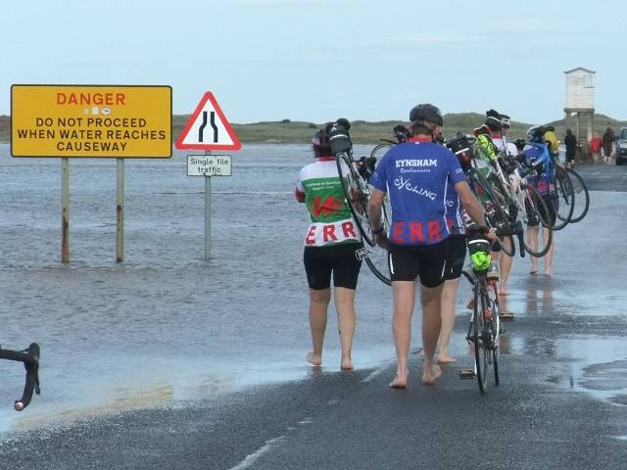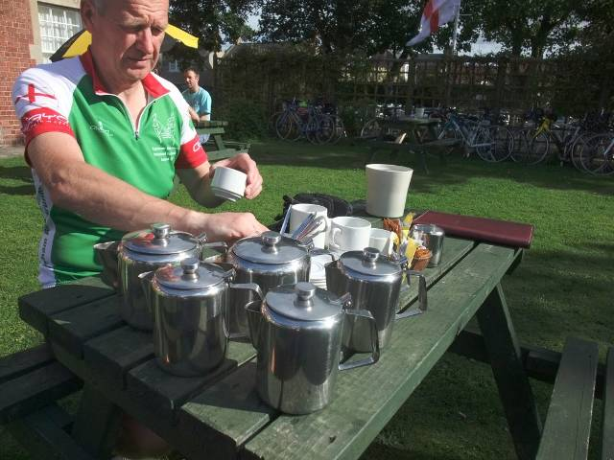
Finally back on our way and on the final leg of the day to Berwick-upon-Tweed. Tiredness was setting in and the full headwind on the causeway back from Holy Island brought us almost to a standstill! We decided to opt for Techno-Boy’s road-route as we weren’t in the mood for any more mountain biking and just wanted to get to Berwick as soon as possible. After a day of glorious sunshine, it threatened to rain on us as we entered Berwick, but mercifully we stayed dry as we finally reached the lovely Travelodge positioned beautifully on a roundabout betwixt Morrisons and McDonalds. I checked Morrisons opening ours, hoping that this would provide us with a good breakfast option but the morrow was Sunday, and alas our breakfast was destined to be either minibus or Macdonalds fodder.
After settling in our rooms and showering, we travelled by minibus to our restaurant for the evening which was found by ***-upon-Tweed. They fed us very well indeed, but I believe the beer was too cold or something, not that I would have noticed!
Day 3: The Day with the Headwind, report by Sparrow
68 miles
6hr 55min
2080m of ascent
Terrain types: tarmac, wood (bridge) and gravel

The truth, the whole truth.....
The day dawned bright and clear, with the sun streaming across the Travelodge car park wherein the youth of Berwick had spent the night frequenting the 24/7 MacDonalds, practicing handbrake turns, and making loud graunching sounds unnervingly like breaking into our trailer or minibus.
FLW had suggested the night before, that we should have a healthy breakfast of bagels, fruit and peanut butter from the back of the minibus, as we had plenty of stock. In the cold light of day, when we realised it would involve standing around in a draughty car par in our cycling kit, we voted with our feet and opted for a healthy MacDonalds instead. It is even possible that Foghorn Leghorn, who has a totally unhealthy view of this reputable catering company, broke her own rules and used the establishment. She would probably claim that she only went in for a pee. It is true that after the lesson of the sumptuous big breakfast at the Premier Inn the previous day, our collective protein intake was rather lower, and the carbohydrate rather higher for most.
9.15 sharp - departure time. As I climbed into the bus driver’s seat, my face revealed not a glimmer of envy or even sympathy as I watched the peleton roll out westwards into a bitter headwind, in a temperature of around 12 degrees before wind-chill factor. ‘Twas not all bad though. The navigation proved much easier, and the road surfaces were more tyre-friendly than Days 1 and 2. Within an hour the sun shone, the Tweed Valley was lovely, and only the wind remained against us, for the morning.
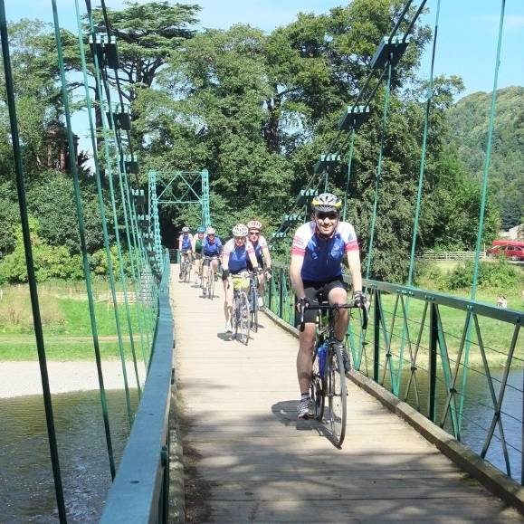
The first meal break was at a quiet junction of green lanes not far from Eccles, (Seagoon’s friend, for those old enough to remember the Goon Show) where there was a welcome relief from the wind, and loads of bagels, fruit and peanut butter left over from breakfast.At 40 miles (Kelso), the drivers changed over, the wind began to drop, and the views became even lovelier (what a jammy sod I am). True, there were hills a-plenty, but all of them were manageable. Two riders decided to relieve themselves of the pressure of keeping up with the group to tiggle along (clue) at their own pace. To the embarrassment of the ‘fastards’, these two tortoises, seemed to finish all the stages at the same time as the hares. We crossed a delightful suspension bridge over the ever-present River Tweed, and before we had finished taking photographs there, the tortoises appeared.
We got lost were let down by the navigation technology on the approaches to the very attractive town of Melrose (NB. My fault, owns up FLW!), and as we scratched around for the proper route out, the tortoises again drifted regally past. The final twenty miles of the day were spent on quiet country lanes running parallel to the main road to Peebles, but on the opposite side of the Tweed Valley. We enjoyed some spectacular views, including watching a local pyromaniac setting fire to patches of gorse. Once again, those infuriating tortoises trundled by.
[Sparrow fails to mention that my bicycle broke down at the final stop of the day, after claiming publically to Spike that I had never had any bother with it: famous last words! FLW]
While running very close to the Tweed, a sign appeared at the roadside “Caution - Canoeists in road”. Intrigued, we approached with due caution, expecting to find either severe flooding, or high tech canoes capable of overland propulsion. It turned out to be a young peoples’ slalom event, and we had to run the gauntlet of exhausted parents, struggling to extract canoes from the foaming brine and drag them a couple of hundred yards back up the road for another youngster to tackle the course. Exciting, but not life-threatening – at least not for us.
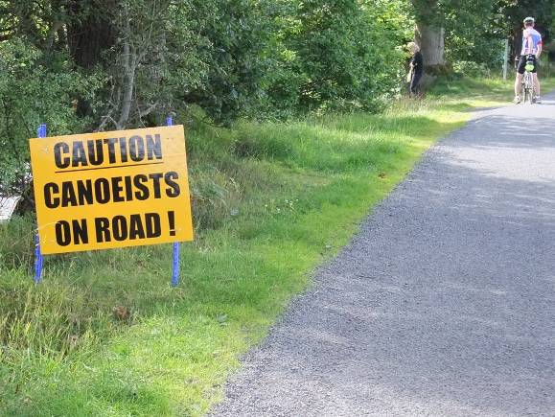
The trip ended at the Kailzie Bunkhouse, just a couple of miles short of Peebles, and set in a delightful location close to Kirkburn Forest. Bollard and the retired FLW had purchased a selection of burnable meat and some highly combustible marshmallows. Techno-Boy and ***-upon-Tweed set about the barbecue. As the sun went down, we dragged a couple of picnic tables to the sheltered side of the bunkhouse, close to where the BBQ was already set up, and enjoyed a delicious repast, accompanied by not a little wine and beer.

Marshmallow toasting was the final challenge, and most of us managed to produce satisfactory-looking individual toasties, until Butt Stripe tried to outdo us all by developing a mass production system. The first batch melted through the bars and caught fire. For the second batch, lessons had been learned and the stick was lifted triumphantly from the hot coals before it could be frazzled, but unfortunately, the whole lot turned to an incredibly sticky goo and was almost impossible to rescue. Gales of drunken laughter...........
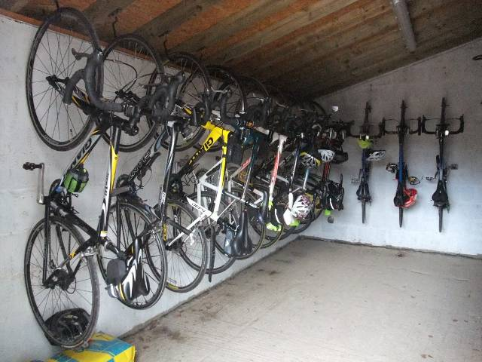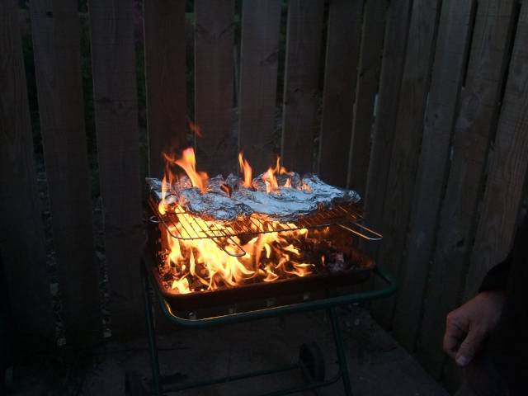
At this point, it became clear that the landlady had previously been hospitalised for a sense-of-humour-ectomy, as we were instructed to make less noise, move the tables back to their proper location, stop barbecuing her prize cockerels, and generally desist from disturbing the tranquility. Naturally we complied, and retired indoors to continue making a noise, insulting her prize cockerels, etc. One problem - there was a lone, and rather uncommunicative visitor sat in the large lounge, flicking through TV channels. On the assumption that this was probably the Mr Grumpy who had already complained that we were keeping his wife awake, we decided that the twelve of us ought to try to make ourselves comfortable in the cupboard next door. So we did, and managed to finish off the wine before retiring.
Retiring, did I say? The delicate sense of decency manifest by the wider Eynsham Roadrunner community precludes the telling of these particular nocturnal activities. Who-slept-with-whom must remain strictly off the record, but suffice it to say the lighter sleepers had to endure the normally private sights and sounds of night-time goings-on, interspersed with excessive creaking of beds, and the crowing of the damn prize cockerels. Broadly, the population was split into two – Old and New, the dividing line occurring around the age of 45. Oldies went upstairs (7 to a room) and the kids (5 in number) went downstairs, where they could have a midnight feast, read under the bedclothes and make it safely to the toilet without falling downstairs.
Of course we said we had slept well, but the impact was to show up in the efforts on the final day.

Day 4: The Rainy Day, report by Techno-Boy
85 miles
6hr 55min
2115m of ascent
Terrain types: tarmac, grass, cobbles, mud, loose rocks and wet paint.

Well our luck had to run out eventually, woke up to find grey skies shortly followed by rain. Lots of rain in fact, but no wind, woohoo! After a leisurely breakfast we all set off in our waterproofs but I think most of us didn’t realise how cold and wet it would be.
5 miles in we started what would be the longest climb of the trip, a 7 mile long steady climb. Despite the rain I tried to soak up the scenery as the King of the Mountains and I led the way.
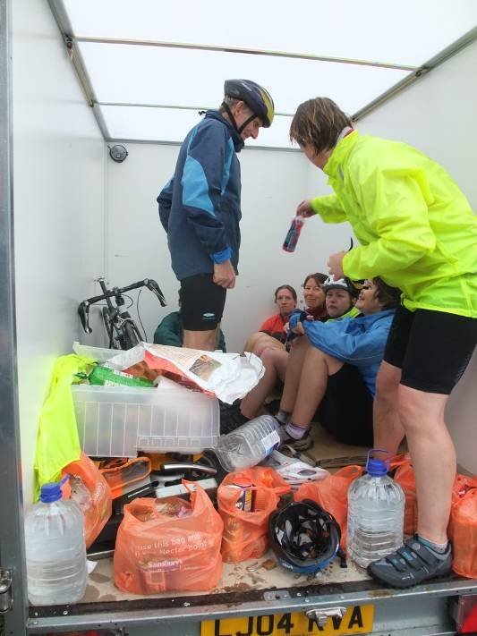
After a freezing long descent and some undulating roads with beautifully smooth glass-like tarmac we reached our first proper stop. That’s when everybody realised that they needed more clothes and we all got changed into dry gear, after huddling into the trailer and eating some food of course.
So we set off again, ready this time, to attack Edinburgh in the rain. That’s when it stopped raining, for now. As we approached the city we cycled along some lovely disused railways, quite a change from the gravel we’d been subjected to on days 1 and 2. Although I didn’t appreciate the wet paint left out on the path for us, as if our bikes hadn’t been subjected to enough already!
We eventually made it to... the tunnel I’d been ranting on about for days! As had been agreed the green jersey was to be awarded in the tunnel sprint, so I made a dash for it in the last 100m, only to be informed that no one else sprinted. Never mind, the green jersey went to Techno-Boy nonetheless.
Exiting the tunnel we soon found ourselves in heavy traffic, wondering why on earth we decided to go through Edinburgh! (well I was thinking that anyway) Oh yes, Edinburgh castle! But before we even reached Princes Street the King of the Mountains got a puncture, probably the worst place in Scotland to get a puncture but at least it enabled The French Lieutenants Woman to get some lovely cups of tea for everyone [actually I think that was Tea-Stop and Butt-Stripe, inevitably, FLW].
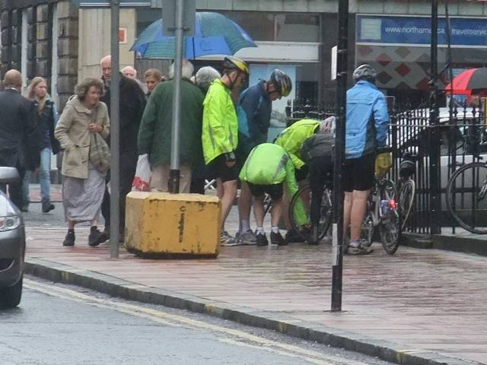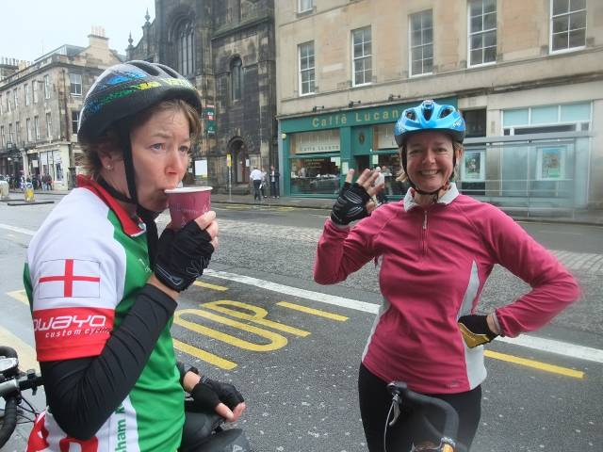
With the puncture fixed we continued to plough through Edinburgh, for about a quarter of a mile before the King got another puncture! After checking the tyre carefully and fixing the puncture we set off only to realise we’d completely forgotten about the castle. But by that time we were a bit sick of cycling in the city so we decided to keep going. It wasn’t long before we reached a decent path taking us out of Edinburgh and on to food stop #2.
And food stop 2 was conveniently placed next to a pub. After watching the French Lieutenants Woman [I seem to be getting a lot of credit for getting hot drinks for people here… I think it was actually Bollard who did the kindness this time, FLW] and ***-upon-Tweed walk across the pub car park carefully balancing some warm coffees I couldn’t resist it any longer so I went and got myself a hot drink. The break also enabled me to examine the state of my bike. It’s never been so muddy, no wonder our brakes were making horrible grinding noises!
Then came the final leg of the journey, taking us over the Firth of Forth and on to Stirling. We set off, in the rain, on what would turn out to be the worst road surface we’d encounter, loose rocks interchanged with mud, and potholed downhill sections (my poor bike...). As we arrived towards the famous Forth Railway bridge we stopped for quick group photo. That’s when I realised my camera was fogging up it was so cold and wet.
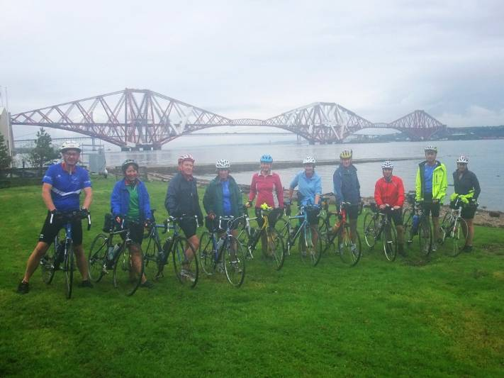

We continued on towards the road bridge, and on the way there I stopped to check everyone was there. Foghorn Leghorn passed me as I waited underneath the bridge, and as I arrived at the top, ready to cross, I was greeted by Foghorn Leghorn, hollering about having won the king of the mountains points for that climb, the cheek! (I don’t think it was technically a point-scoring climb but I thought I’d let that one point go to Foghorn, after all the King of the Mountains and I were level pegging on about 1270 points each for the polka dot jersey).
We carried on over the bridge, flouting the ridiculous 15mph speed limit, and continued on to the other side of the estuary. We followed some nice paths along the shore, to be greeted by a cobbled uphill section, which I foolishly decided to sprint up.
[How could you forget the minibus incident, Techno-Boy? FLW]

It wasn’t long before we all started thinking about the mystery last night location... would it be a spa, a luxury hotel, maybe even a castle?
With one last final uphill section we all reached our final destination, Broomhill Castle! We were so muddy we went round the back and hosed down our bikes... and our jackets, our legs and our shoes, while sipping our celebratory Drambuies, courtesy of Sparrow. [3-Bikes in particular seemed to having her arsed hosed down…FLW].
After a well deserved shower we wolfed down a tasty three course meal and retired to the bar to sample some more Drambuies, and Scotch whisky of course.
Although this final day was to be the longest with the most amount of climbing, it somehow didn’t seem to be as tough as the previous day, maybe it was the lack of wind.
Day 5: The Return Journey, report by Bollard

Notwithstanding our final resting place was a castle, (no not that final resting place) we needed to visit our final castle in Stirling. So after a full monty Scottish breakfast including haggis and black pudding we headed off to Stirling.
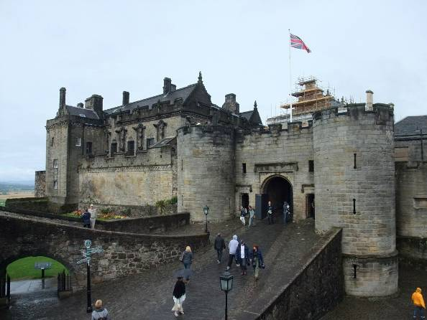
Fierce negotiation by the French Lieutenants Woman got a discount on our tickets for the castle and, as luck would have it, we were able to join a tour that had just started. Clearly the guide was a budding thespian who led us through centuries of “living history” not of course missing the relevant battles with the old enemy. With Bannockburn and the memorial to William Wallace being but a stones throw away, (well maybe you would need a Trebuchet) there was quite an edge to the visit. Alas, with the prospect of a long and slow journey home our visit needed to be brief, and so we returned to our own castle to collect the luggage and the trailer.
To ease left hand turns on the journey, Sparrow had made a last minute adjustment to the trailer. It did of course have the disadvantage of making right hand turns more difficult!
Although there were 4 drivers (not all at once of course) it took the brave ***-upon-Tweed to volunteer for the first leg and try out the newly adapted trailer. He remarked that it followed well, albeit wanting to overtake at regular intervals. As ever it was simply a case of getting used to another idiosyncrasy within our transport; clapped out engine, broken sliding door that let in the rain and refused to close, rear doors that wouldn’t open, pedals too close together and, as we were to discover later, no light on the dash board.
At an average speed of 47 miles an hour our journey of 380 miles was slow. Tedium was overcome by the task of rolling past lorries on the downhill stretches of the motorway and seemingly pedalling frantically to ensure they didn’t re-overtake on the up hill stretch. It would probably have been a quicker journey if the minibus had been powered by our combined pedal power.
Our last castle was sighted at Stafford, shortly before sunset, after which there was no prospect of reading to pass the time. The King of the Mountains had already read War & Peace, and Techno-Boy was onto the 24th episode of 24 on his iPad. The drivers came and went, burned out, I guess in the same way the drivers at Le Mans. My turn came at the Services on the M5, west of Birmingham. I had been saved for this stretch as I spoke the language and would therefore have no difficulty in explaining to the police why we could only travel at 30 miles an hour up hill. Luckily my language skills were not needed and we limped into Eynsham at around 10.30.
A speedy unloading of the trailer and reassembly of the bikes saw Sparrrow and The French Lieutenants Woman depart to deposit the adapted trailer at John Bustin’s (not sure they would appreciate the modification) and the remnants of the minibus at TVR.
Once again the anti-socialists had faced a significant challenge, tackled it head on, and succeeded, as was to be expected.
All that remains are some unanswered questions;
Will Techno-boy ever take his new bike out again?
Is the French Lieutenants Woman’s bike beyond repair?
Will 3-Bikes ever be satisfied with just one in the future?
Will ***-upon-Tweed buy new wheels for his bike?
[I am sure she will as it was a lovely ride, thank you 3-bikes, Sparrow, Bollard and Techno-Boy for the fantastic bike swappage that allowed me to ride the final day! FLW]

