L’Etape du Tour 2010: The Back End – on the run from the Car Balais by Marie Chuilon
(added comments by Ben Chuilon and Daniel Talbot-Ponsonby)

Sunday 18th July 2010. The alarm went off at 3:50a.m. local time but I had made the mistake of not changing my clock so I could see that it was 2:50a.m. UK time, and it felt like it too. (Ben on the other hand, had barely slept as he was too excited). I went downstairs in a zombie-like state for breakfast and then got my things together for the coach. It was still dark when we arrived in Pau where our bikes had been racked overnight. People with head torches took our tickets and headed off in search of our bikes, bringing them back still damp from the dew. It was freezing.

There was a short bike ride from the collection point to the start of the event and as we cycled over the sun began to rise. After a few laps around the middle of Pau looking for signposts we eventually made our way into our pen to find over 5,000 people stood ahead of us and a very smelly toilet next to us. We couldn’t see the start.

At 7:00a.m. the race began. Or at least I think it did, there wasn’t much movement in the crowds ahead for some time. Eventually the crowds directly ahead of us began to move and we got on our bikes for a short cycle to the start, and then we were off. The beginning was a gentle downhill and people sped off, eager to get to the challenge ahead.

We continued apace for some time, with the occasional stop in villages as the sheer volume of riders became too much for the narrow roads and we all bunched up. Dan and Ben had gone on ahead of me already and I think they managed to avoid some of the jams. (nope, we hadn’t missed them)

Eventually we reached the first proper climb of the day. The Col de Marie-Blanque was 9.5km with an average 7.5% incline, and several kilometres reaching gradients of 12% nearer the top. I was feeling very good at this point and started chatting to people and singing along to myself. Around halfway up the climb I saw Ben ahead of me and managed to catch up enough to speak to him briefly before we got separated again. (I was following the advice given to us before the start and taking it easy on the first climb, a little too easy though so when Marie caught me up, I naturally sped up a bit). People were already starting to walk and by the time I’d reached the 1k to go sign there were too many walkers for me to be able to cycle any more. I was forced to walk and complain loudly (a real shame as we were both feeling confident and climbing well).

Once I reached the top I was able to get back on the bike and cycle on to the first food stop. Ben was waiting for me at the stop and we compared stories of the first climb. It was a nice stop until we realised we were somewhere near the back and should probably get a move on. We cycled a fast flat section into the wind trying to make up some time. Nobody was forming groups so I sat on Ben’s wheel as much as I could. I was very relieved to make it to the second food stop (which was also the first official cut-off point), but with only 20 minutes to spare. No time for a rest, go, go, go. Ben grabbed some food while I held the bikes and then we headed off, eating on the bike.

By this time we were at the bottom of the Col du Soulor, the second major climb of the day and the longest: 22km at an average gradient of 5% with long sections reaching 7.5%. Ben went on ahead, anxious to make up some more time. I plodded on behind.

The Soulor was one of the highlights for me. The first half of the climb wound up through sloped fields and small wooded sections of road, with fantastic views of the Pyrenees. Many people had stopped for a breather in shaded areas but I felt good so I kept going. Every km is marked by a signpost indicating the next section’s gradient and these kept increasing, 5, 6, 6.5, 7%... this climb is a long grind. Not only that but it was hot, 32 degrees-hot, and by the time I got to the last 5km the shade had all gone, replaced by a rocky landscape. I should have stopped earlier, but with nowhere to hide from the sun I decided to keep going and rest at the top.

I also enjoyed the Soulor as much as any climb I have ever undertaken. Despite the gradual increase in gradient towards the top there were no really steep sections, so it was possible to establish a rhythm and tap away without being in danger of getting into the red. The scenery was breathtaking and the writing on the road and crowds at the top gave a small sense of what it must be like to ride in the Tour itself. For the last 200 yards you had to pick a path through the spectators flooding onto the road.

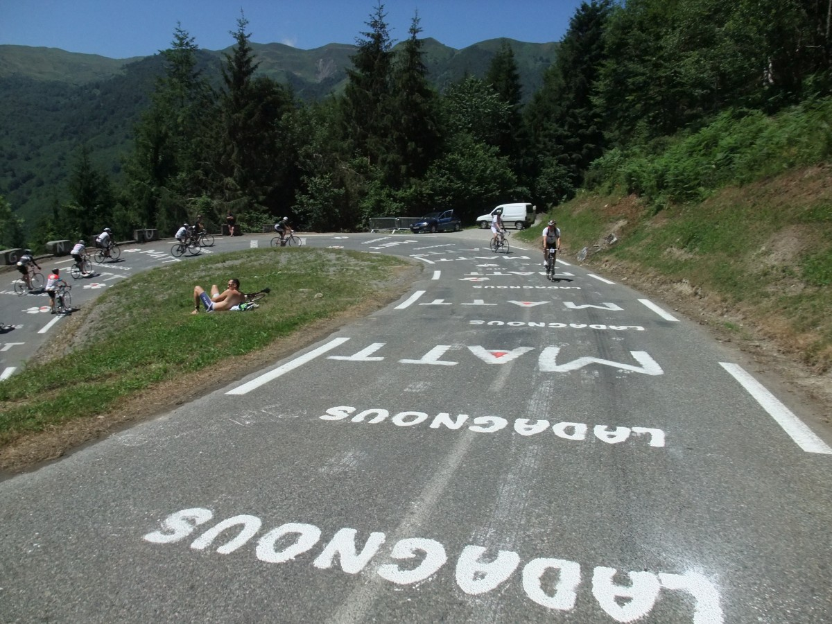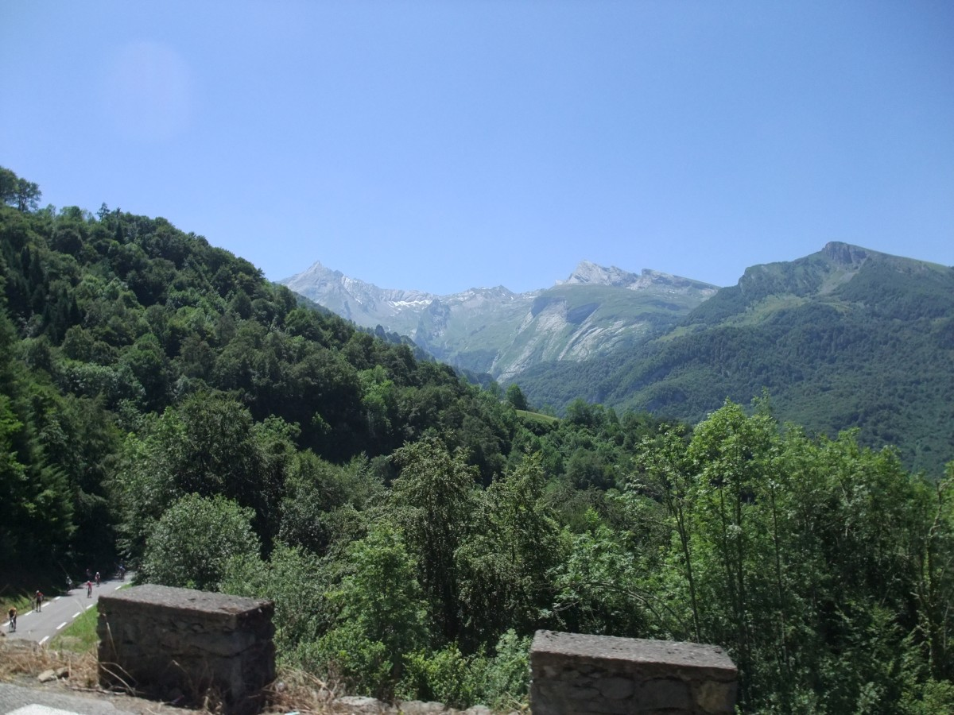

It was long and slow but as I neared the top there were crowds gathered, excitedly shouting ‘Allez la fille!’ and offering to throw water over me. I declined, for now. At the very top there was even an ‘Allez la fille’ chant that one group were shouting in the direction of any female cyclist. It put a big smile on my face.

Ben was waiting for me at the top, but I couldn’t stop for fear that I wouldn’t get going again so I shouted that he should catch me up on the way down. It didn’t take him long to catch me as I braked far more than I probably needed to.

I reached the third, and final, food stop with only 5 minutes to spare. I think we may have managed to grab one item each before rushing off. I was very tired by this point and just wanted to get off my bike for a few minutes so we stopped at the French Cycling Holidays stop where there were ham sandwiches, coffee and chairs. We were joined by a couple of the injured who had decided not to carry on. Ben decided he wanted to try to make up some time so he went on ahead. I got back on the bike too and set off up the col du Tourmalet, the last major climb of the day. (The Tourmalet was indeed the main event, 19km at an average, and steady, gradient of 7.5%).

I was on my own for what felt like quite a long time. It was incredibly hot on the exposed, airless roads and I focussed on just pushing the pedals. I cycled through spooky sections under bridges where cyclists sat silently in the only shade available. The final village that we passed through was incredibly steep. There were a lot of spectators who poured water over me and pushed me up the hill, which was a great relief for 30 seconds or so. (I got so many spectators to pour water over me that I was more soaked than I’ve ever been on the bike in the UK! But it felt lovely as the temperatures were still in the high twenties and I was still, most definitely, going uphill).

I reached the final water stop, just 10k from the finish. I couldn’t see where to get the water or where the route headed to next. There was a lot of confusion so I asked someone what was going on. They said we had to decide whether or not we were going to carry on as we were on the cusp of the cut-off and the coaches were coming. I was worried about carrying on alone and still hadn’t found any water. As we were dithering a French marshal shouted ‘That’s it – everybody on the coach!’. We all moved obediently towards the collection point. People were still arriving behind us and were being herded in the same direction. I realised that this was also the direction of the route, and there were far too many people for a coach (which hadn’t arrived yet). I started to suggest to others that we should carry on. Most of them declined, they’d had enough. I texted Ben who replied with words of encouragement and, after managing to get some water from one of the people getting the coach, I got back on my bike and cycled off before the marshal could stop me.

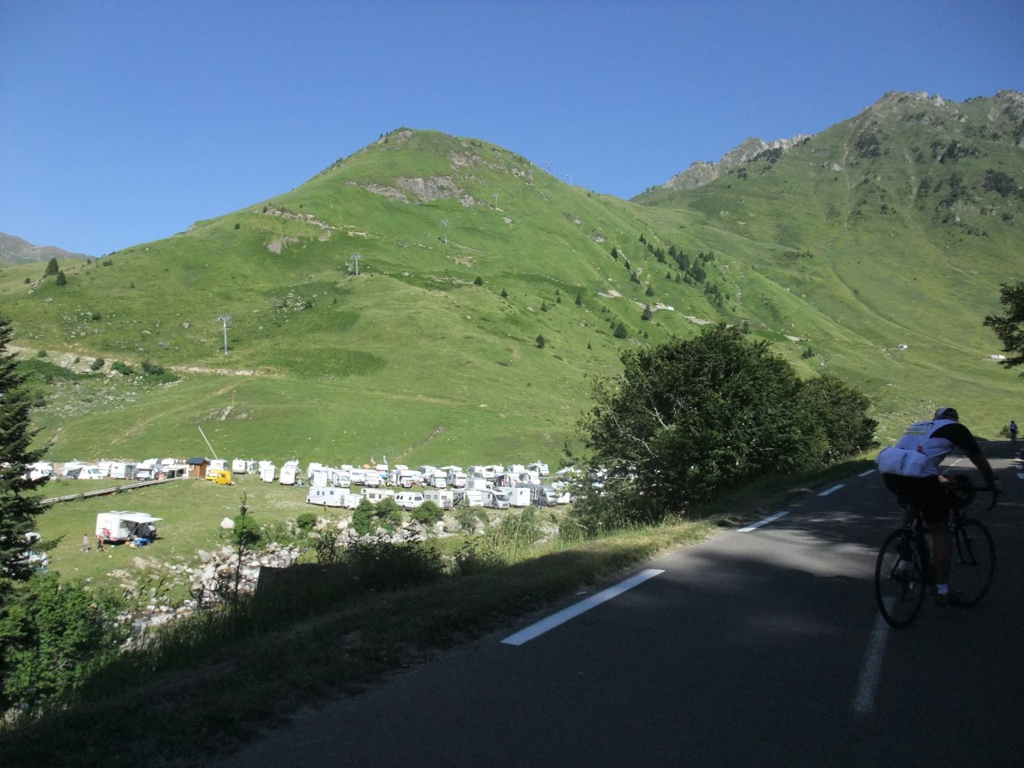
At that point I was plodding along with a good rhythm: keep grinding, have a sip of energy drink, keep grinding, have a sip of water, take a photo, stand up on the pedals for a bit, back in the saddle for more grinding, and repeat. It was ok really, the end was close and the spectator support was great, although they were thinning out fast. One rider who’d given up said I’d earned my jersey which reads “Tourmalet”. “Not quite earned it yet” I thought to myself, but the sight of other riders having given up was actually... encouraging.
the road ahead

It’s hard to overstate the effect of people giving up around you. Maybe I’m strange, but it gives a huge boost: your main thought is “they’re in a worse state than me”. You listen for people gasping for breath and take encouragement from the fact that you are gasping less than them. Then you go back to concentrating on making the pedals turn again. And again.

I had a little “moment” 6 km or so from the top. My gps had long since given up so I was relying on the intermittent signposts to gauge my progress. I had decided that I was nearly there, but then turned a corner around the last spur and could see the top for the first time. It was miles away. And miles above me. Suddenly I felt I was cycling through treacle and for the first time entertained doubts about whether I could get there. However, after stopping for some gels and some halting but friendly conversations with the ever-present spectators I firmly told myself to stop being such a wuss and got going again. With that behind me I was able to enjoy the ever-expanding vista in the knowledge that I was on the home straight.

The rest may have done me some good as I quickly started catching up with people, many of them walking. I managed another 5k before the coaches went past filled with tired cyclists. I kept a keen eye on the 1km markers and promised myself a rest as soon as the gradient increased but it maintained a steady 8-9% for most of the way. I stopped at one point to eat a banana and get some shade. There were a lot of people sat at the side of the road waiting to be collected. Some of them were stopped because their husband/wife had stopped, and some because they realised they were outside the cut-off time but I wanted to prove that I could finish, regardless of the time – I wasn’t going to let it beat me now.

Gradually, the roads became more winding and I started to get a different aspect of just what I was climbing. I could see up for miles above and below me. (a case of “don’t look up” for me). The cyclists behind me were small specks in the distance. I said out loud ‘I did that! I did it all by myself’. I got a couple of strange looks but it made me smile.

Eventually, with 1k to go the sign indicated that things were about to get a lot steeper. I felt ok but stuck to my promise to stop. I stood at the side of the road and shoved my last chewy bar into my mouth then I got back on and ground my way to the top.

(By that time I’d finished what was the most fantastic and tough ride I’ve done to date, and I knew straight away that I will be doing the Etape again).

Sadly, the organisers were packing up when I reached the top and my exhaustion meant that I didn’t quite feel the elation I had anticipated. Someone thanked me for making them get back on their bike instead of on the coach. Then I got back on my bike and headed down to the ski resort to pick up my medal and meet up with Ben. I was spent, I had absolutely nothing left. The hardest cycling of the day was the 12 miles back to the pick up point through heavy traffic as night was falling. But that was ok, I was allowed to feel tired and emotional at this point. I had scaled 3 mountains, cycled for 12 and a half hours barely stopping, battled it out in 32 degree heat, and I did it all with just my own power and determination. And it was worth it.

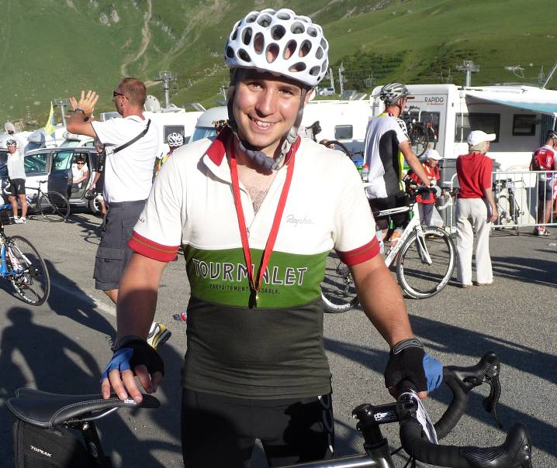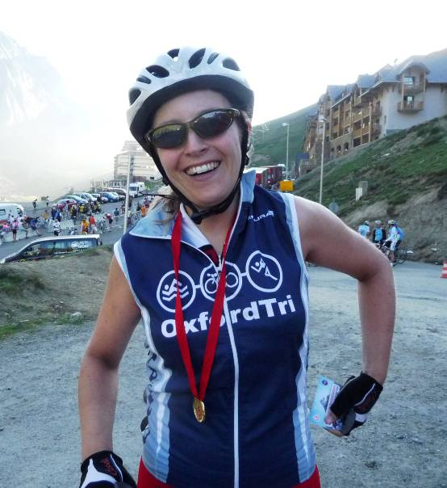
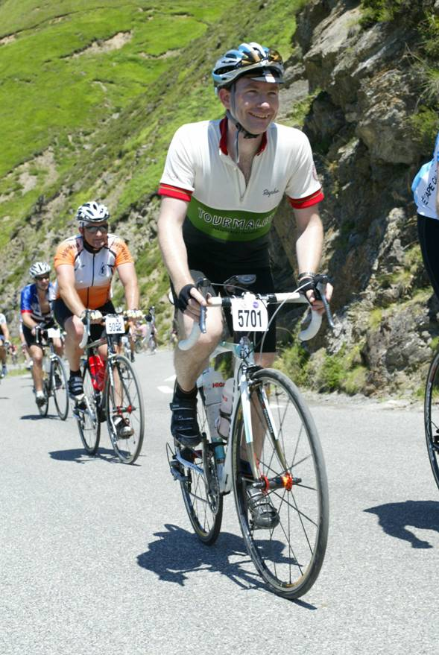
It should be noted that the route was 180 km (112 miles) long (not counting the descent back to the bus) with somewhere between 4,500 m and 5,000 m of ascent. That’s three vertical miles. Ben Nevis three times. Mont Blanc from sea level. It was generally recognised as the hardest Etape for some years, and I can vouch for the fact that it was much harder than last year. Starting the climb of the notorious Tourmalet with 100 miles and 3,000 m already in the legs is one of life’s great experiences and I would recommend it to anyone.

For the record – since the timing mats were still there when I finished – I came in at number 5657 (out of 10,000 starters) in 10:35:00, taking 2:09:26 to climb the Tourmalet.

