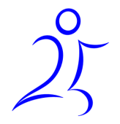
ERR 25th anniversary
250 mile cycle challenge


Much Birch loop – half day
- 30 miles (48 km)
- 1830 feet of ascent (550m)

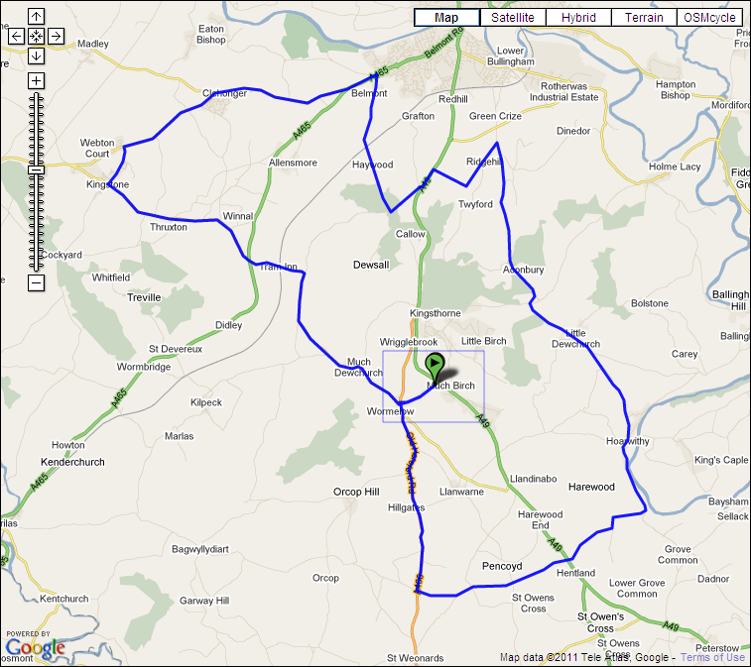

An easy half day cycling around the local area to get the legs going.
Forest of Dean

- 72 miles (116 km)
- 1910m ascent (6370 feet)

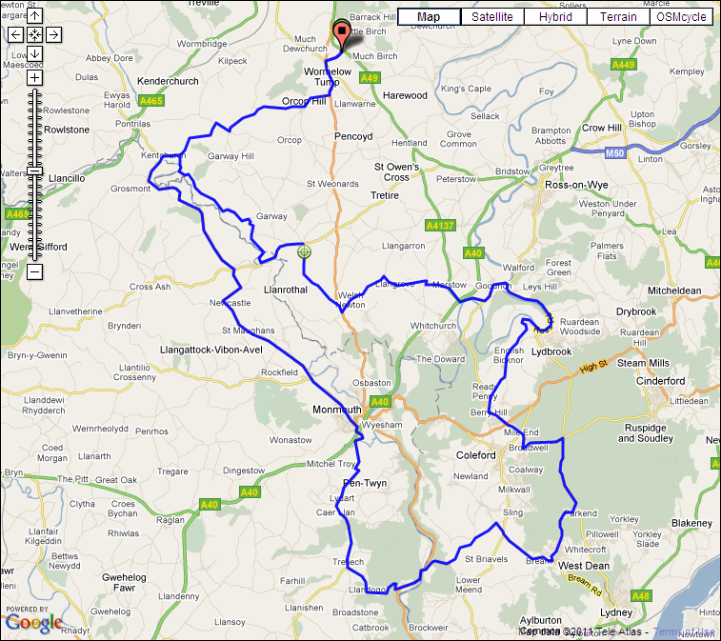
optional climb
alternative

Possible food stops:
Dog and Muffler in Joyford (30 miles)
Royal Forest Inn in Mile End (31 miles)
The Rising Sun in West Dean (37.5 miles)
Pub, co-op or Waitrose in Monmouth (51.5 miles)

This will be a challenging day through the lovely Forest of Dean. None of the climbs are very long but there isn’t much flat either. There is an optional climb for those who fancy an extra challenge, a short steep section at LLandogo which reaches a gradient of over 20%!

There are several places to stop for food along the way and also the option of grabbing some carbs from the supermarket in Monmouth.
Wye Valley

- 67 miles (180 km)
- 4000 feet of ascent (1215m)

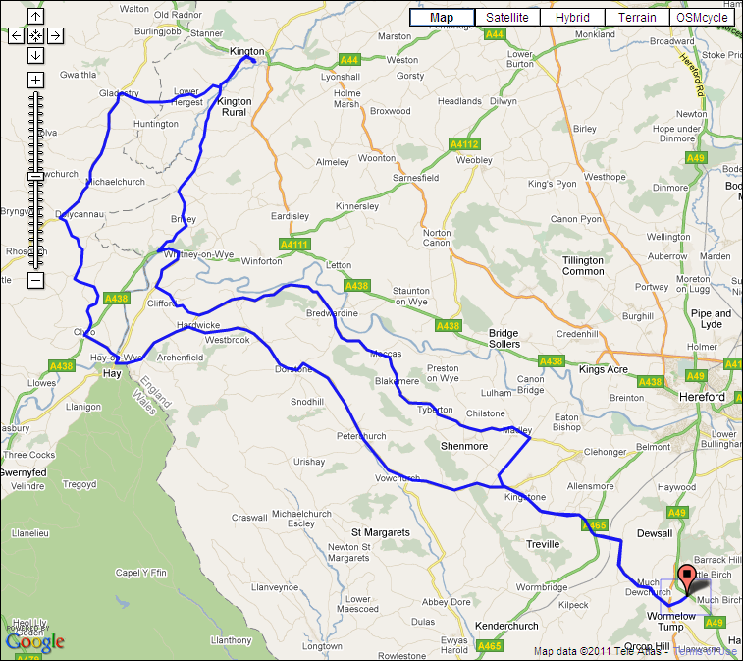
possible food stop in Kington

Possible food stops:
Pub stop or stop at a co-op in Hay-on-Wye (22 miles)
Pub stop or co-op in Kington (36 miles)

A fairly easy day in the Wye valley with only four moderate climbs. The biggest of which is about 2.5 miles long, shortly after Hay on Wye. There aren’t many places to get food from so a stop in Hay-on-Wye or a possible 3 mile detour into Kington are probably the best options.
Black Mountains

- 85 miles (137 km)
- 7400 feet of ascent (2220m)
(6300 feet or 1900m on alternate route)

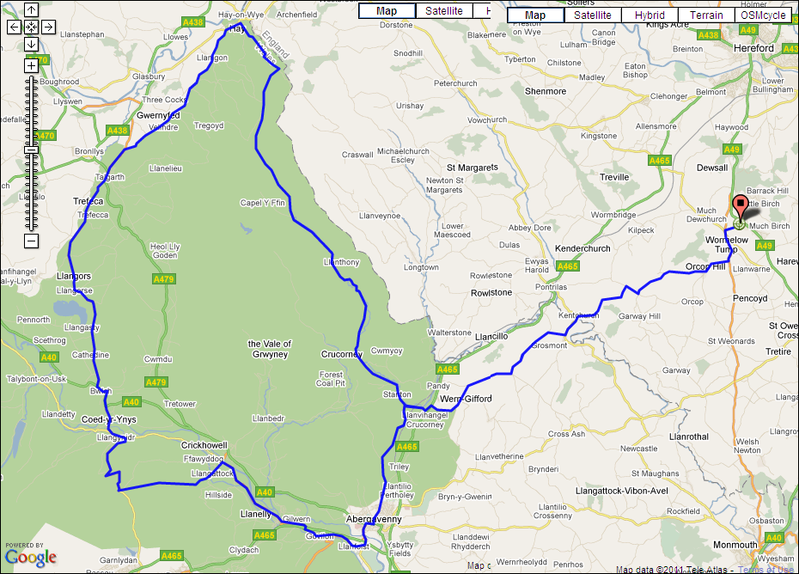
optional climb
alternative

Possible food stops:
Pub or co-op in Hay-on Wye (32 miles)
Co-op in Talgarth (39 miles)
Pub stop in Gilwern (60 miles) or Abergavenny (65 miles)

The longest day takes us into the beautiful Black Mountains for another memorable ride. Although this is route is longer with slightly more ascending than that in the Forest of Dean, it might not feel quite as tough as the climbs aren’t as steep and there are some flatter sections on which to rest a bit. Again, there is an optional climb from Llangynidr over to Llangattock. This one however isn’t short and steep but rather long and... steep...ish. 2.5 miles at an average gradient of 8%, fantastic!

As we will be passing though several towns there should be plenty of options with regards to stopping for food.

(Taking the optional climb out brings the total ascent down to 1900m or 6300 feet)

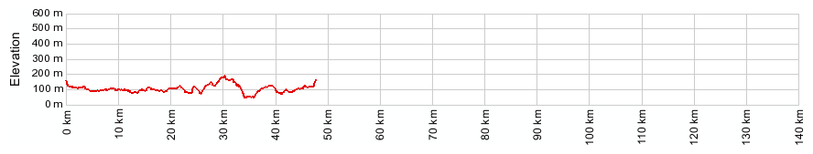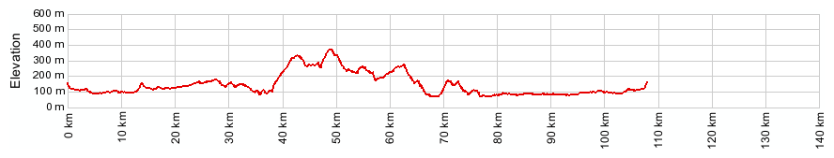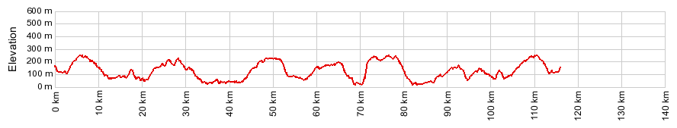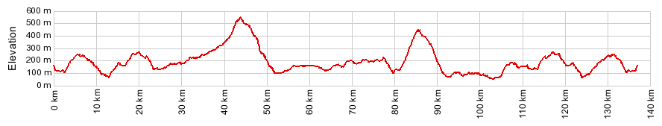
Much Birch 30 miles
Wye Valley 67 miles miles
Forest of Dean 72 miles
Black Mountains 85 miles
optional climb
optional climb

